**6.**

**You should populate your data warehouse tables based on the data in the sample tables and spreadsheet. You do not need to write SQL INSERT statements or insert data into database tables. You can just show table listings in your solution. You should indicate mappings from data sources into tables. For example, a mapping may involve generating new primary key values for a data warehouse table or using a default value for a missing value.**

FitnessFact fact table



Calendar table

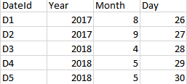

Sale table

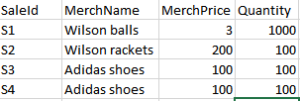

Franchise table

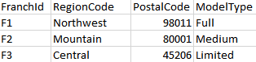

Member table

